Chapter 3, Solution 38

Consider the circuit below with the mesh currents.

4 Ω
3 Ω

I₃
+
_
60 V
1 Ω
I₄
10 A

2 Ω
2 Ω
Io
1 Ω
+
_
I₁
I₂
22.5V
1 Ω

4 Ω

5 A

I₁ = –5 A (1)

1(I₂–I₁) + 2(I₂–I₄) + 22.5 + 4I₂ = 0
7I₂ – I₄ = –27.5 (2)

–60 + 4I₃ + 3I₄ + 1I₄ + 2(I₄–I₂) + 2(I₃ – I₁) = 0 (super mesh)
–2I₂ + 6 I₃ + 6I₄ = +60 – 10 = 50 (3)

But, we need one more equation, so we use the constraint equation –I₃ + I₄ = 10. This now gives us three equations with three unknowns.

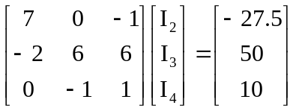

We can now use MATLAB to solve the problem.

>> Z=[7,0,-1;-2,6,6;0,-1,0]

Z =

7 0 -1
-2 6 6
0 -1 0
>> V=[–27.5,50,10]'

V =
–27.5
50
10
>> I=inv(Z)*V

I =
–1.3750
–10.0000
17.8750

I_{o} = I₁ – I₂ = –5 – 1.375 = –6.375 A.

Check using the super mesh (equation (3)):

–2I₂ + 6 I₃ + 6I₄ = 2.75 – 60 + 107.25 = 50!

